**EXERCISE NO:8**

**DATE: 21/11/2020**

**AIM:**

 To get a list, sorted in increasing order by the last element in each tuple from a given list of non-empty tuples.

**PROGRAM:**

 def last(n):

return n[-1]

def sort_list_last(tuples):

return sorted(tuples, key=last)

print(sort_list_last([(2, 5), (1, 2), (4, 4), (2, 3), (2, 1)]))

**LINK:** <http://103.53.53.18/mod/vpl/view.php?id=317&userid=1695>

**OUTPUT:**

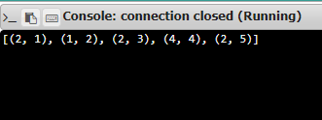

**RESULT:**

Thus the list is sorted in increasing order.